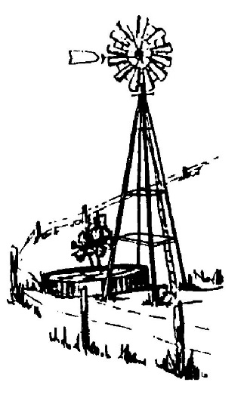
S. S. WATER SUPPLY CORPORATION

REGULAR BOARD MEETING

AGENDA

Monday, May 08, 2017

7:30 P.M.

Call to Order

“In God We Trust” Moment

Pledges of Allegiance to the Flags of the United States and the State of Texas

Roll Call:
- Board Members
- Staff
- Guests and Members

AGENDA ITEMS

1. Minutes – Consideration and/or action regarding the approval of the minutes of the
Regular Meeting of April 10, 2017.

2. Customer Concerns

3. Member’s Forum

4. President’s Report

5. Treasurer’s Report – Consideration and/or action regarding the approval of Checks Written in the month of April, 2017, Account Reconciliations and Financial Statements for the month of April, 2017.

6. General Manager’s Report

- TCEQ Inspection
- Texas Aquifer Conference

7. Systems Operator’s Report – System Outages, Repairs, and/or Leaks

8. Office Manager’s Report – Billing Incentive Program Update

OLD BUSINESS

9. Discussion and/or Status Reports on Projects:
- Project 16-08 Upgrade CR 319 Pump Station
- Project 16-05 6” Line Extension on Water Street

10. Capital Improvement Fee Fund – Consider and/or action to allocate particular funds to the Capital Improvement Fee Fund.

NEW BUSINESS

11. 2016 Tax Return – Consider and/or take action to approved the Corporation 2016 Tax Return.

12. Employee Recognition Initiative – Consider and/or take action regarding a new initiative recommended by Director Ron Branyon.

13. 2017 Corporation Christmas Party – Consider and/or take action regarding venue, budget, and entertainment options for the annual Christmas Party.

14. Project 17-02 - Upgraded Exterior Property Illumination – Consider and/or take action regarding approval of a bid from G&M Electric Inc. in the amount of $2,316.69 to upgrade exterior property, sign and flag pole lighting to LED.

15. Project 17-03 – Operations Audio Visual Upgrade Project – Consideration and/or take action regarding approval for the purchase and installation of a computer system and large flat screen monitor/television for the Operations Building not to exceed $3,000.

EXECUTIVE SESSION

Called under Section 551.071 of the Texas Government Code Vernon’s Civil Statutes, Subchapter D, as it pertains to private consultations with the Board’s attorneys, as it pertains to the purchase, exchange, lease or value of real property, as it pertains to personnel, and as it pertains to security. The Board will then reconvene in Open Session and will be asked to take appropriate actions on matters presented in Executive Session.

- Proposed Location Filter/Land Purchase

RECONVENE TO REGULAR SESSION

16. Consider and/or take action deemed necessary as a result of the Executive Session.

17. New, Re-serviced, Transferred, Cancelled, and Reinstated Memberships- Consideration and/or action regarding approval of new, re-serviced, transferred, cancelled and reinstated memberships.

ADJOURNMENT

_________________________

John Larrison, President

I, ASHLEY N. LINDSEY, ADMINISTRATIVE ASSISTANT OF THE S.S. WATER SUPPLY CORPORATION, LA VERNIA, TEXAS, DO HEREBY CERTIFY THAT THE ABOVE AGENDA WAS PREPARED AND POSTED ON THE OFFICIAL WEBSITE OF THE CORPORATION ON THIS 5th DAY OF MAY, 2017 AT 2:38 PM, WHICH IS A PLACE READILY ACCESSIBLE TO THE PUBLIC AT ALL TIMES AND THAT SAID NOTICE WAS POSTED IN ACCORDANCE WITH CHAPTER 551, TEXAS LOCAL GOVERNMENT CODE.

Ashley N. Lindsey
Ashley N. Lindsey, Administrative Assistant

This Notice is posted pursuant to the Texas Open Meeting Act. (TEX.REV.CIV.STAT.ANN. Chapter 551) S. S. Water Supply Corporation will hold an open meeting at 7:30 p.m., Monday May 08, 2017, at the BUSINESS OFFICE, 08393 U.S. Hwy 87 W, La Vernia, Texas. For more information call 830-779-2837.

This facility is accessible in accordance with the Americans with Disabilities Act. Handicapped parking spaces are available. If you require special assistance or have a request for special services please call (830) 779-2837 at least 24 hours in advance of the meeting.

